BASICS IN COMPUTER LEARNING

By

Jittin .V. Mathew, SDB

**Table of Contents**

**CHAPTERS PAGE NO.**

1. BASICS IN COMPUTER LEARNING 03
2. HOW TO ON/OFF COMPUTER 04
3. HOW TO USE PAINT 09
4. HOW TO USE MS- WORD 11
5. HOW TO USE MS- POWER POINT 13
6. HOW TO USE MS- EXCEL 18
7. HOW TO USE MS- ACCESS 25
8. HOW TO USE HTML 29

**BASICS IN COMPUTER LEARNING**

**HARDWARE**

Parts of computer which can be touched and felt

# External Hardware

1. C.P.U. Box
2. Mouse
3. Keyboard
4. Speakers
5. Printer
6. Headphone
7. Microphone
8. Scanner

# Internal Hardware

* 1. Mother board – contains main processor
  2. Smps (Switch Mode Power Supply)- supplies power/ electricity to computer
  3. Hardisk- stores data

**SOFTWARE**

They are set of programs needed to run the computer.

Programs are the set of instructions or commands which are required to tell the computer what to do?

# System Software

Set of Programs that are required for operating and managing the computer Eg- Operating system- Windows 98

Operating system is the software that starts working when you start your computer.

# Application Software

Set of Programs that are required to perform a certain task. Eg- painting

**HOW TO START COMPUTER?**

**Switch ON** the **main power supply**.

Press the **Start Button** On the **CPU (**Central Processing Unit**)**. Select the **login** and press **Enter or Single Left click of mouse**.

# HOW TO SWITCH OFF THE COMPUTER?

Press  **START**

Click **Shut down**.

# HOW TO USE THE MOUSE?

It is used to **Select.**

**LEFT Button**

* It is used to **SELECTany file. Pictures, folders**



**RIGHT Button**

* It is used to **DISPLAY (SHOW) set of commands**

# STEPS:

**HOW TO START A PROGRAM?**

To start a program or to open any files, folders or pictures, music, videos.

**Double** Click **LEFT** Button

# HOW TO Drag and Drop?

It is used to **MOVE any files, folders or pictures, music, videos** from one location to another. Place the **MOUSE** over **any file, folder or picture, music, video you want to move.**

Click the **Left Button of MOUSE** and **while holding the button down,**

# move (drag) the MOUSE to the position you want to place the file, folder or picture, music, video and then leave the button.

1. **DIFFERENT MOUSE POINTERS SHAPES:**

 **Busy:** It means computer is **BUSY, wait for some time.**

# Normal: you can SELECT, POINT and DRAG the Files.

**Double Head Arrow:** For **ADJUSTING SIZE** of the **Screen window**

# Pictures

**Four Head Arrow:** for **moving** pictures

# Toolbar



**(bar at theBottom-down of Desktop)**

I **BEAM:** For **WRITING** in a document.

1. **IMPORTANT NAMES IN COMPUTER:**

**Desktop-** colorful main screen seen on your monitor.

**Icons**- small pictures or symbols used to open different files or programs

**TaskBar**- It is long strip or bar at the bottom of the screen. It has Start button, active programs and clock.

**Start button**- It is used to start any programs or various applications.

**All Programs**- It displays a list of various programs. **Documents**- It displays a list of recently used documents. **Settings**- Help in changing window setting

**Find**- Help in searching your files / folders in computer.

**Clock-** It shows time, date, day when you place your mouse pointer on it.

1. **HOW TO SET TIME, DATE, WALLPAPER AND SCREEN SAVER:**

**To set the Time**- Double Click the clock in taskbar- click on hours / minutes / seconds depending on what you want to change- Apply.

**To set the Date-** Click on month, list of month appears- Select current month- click on year. Select the year by using up/down button- click on correct day in calendar- Apply- O.K

**Wallpaper-** Click START button- Setting- Control Panel- double Click on Display icon- Click on Background tab- Select Picture- Apply- O.K

**Screen Saver-** Most of the time the Computer is ON for some time without any use. During this time a picture appears on the screen. This picture is called Screen Saver.

**To Change Screen Saver-** Click on the Screen saver tab in Display properties window- Select screen saver- enter time (in minutes) in wait box- apply- O.K

**Appearance-**Changes appearance of your window i.e. its color scheme, style, font size etc.

**To Change Appearance**s**-** Click Appearance of your window i.e. its color scheme, style, font size etc.

# Shortcut KEYS

**ALT + F4**- closes the program

**ALT + TAB**- shows the multiple programs which are working

**CTR+ Z-** undo

**CTR+Y-** redo

**CTR+C-** copy

**CTR+V**- paste

**CTR+X-** cut

**CTR+P-** print

**CTR+A-** select all

**SHIFT-** upper case

**CTR+S-** save

**SHIFT+ ALPHABET**- CHANGES THE SIZE Small (f) TO BIG (F)

1. **HOW TO RENAME, DELETE, COPY, AND CUT A NEW FOLDER? Select** the File or Folder you want to rename

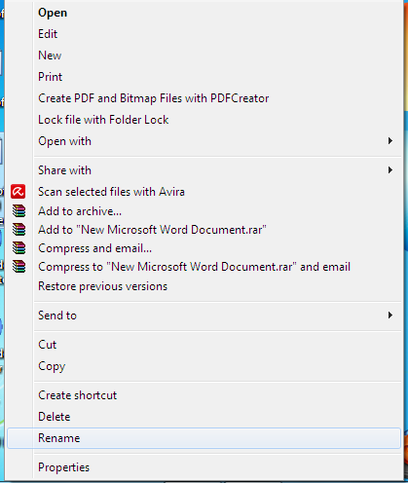

Click **Right button of mouse- Select Rename**

**Select Delete Select Copy Select Cut**

# HOW TO MOVE A FILE/ FOLDER?

**Select** the File/Folder

# Click Right button of mouse- Select CUT

Open the folder/file where to MOVE

Click **Right button of mouse- Select Paste**

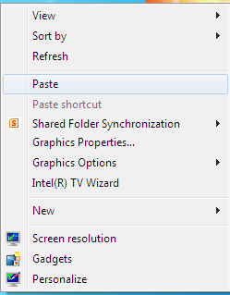

# HOW TO USE PAINT?

**Go to START – ALL PROGRAMS- ACCESSORIES- PAINT**

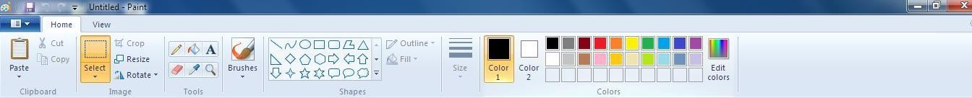

**PENCIL**

**Colors**

**Select to WRITE**

**SHAPES**

**MAGNIFIER**

**ERASER**

**Background Color**

# PICK COLOR

1. **HOW TO OPEN A NEW FOLDER, MICROSOFT WORD DOCUMENT, MICROSOFT POWER POINT PRESENTATION AND MICROSOFT EXCEL WORKSHEET?**

Click **Right button of mouse** on Desktop Select **NEW**- Click **FOLDER**

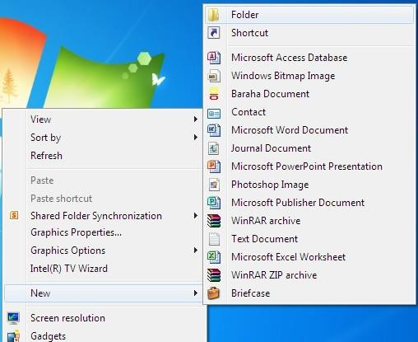

Click on **Microsoft Word Document**

Click on **Microsoft Power Point Presentation**

Click on **Microsoft Excel Worksheet**

**HOW TO USE MS- WORD?**

**How to Create a New Document in Ms- Word?**

Click FILE Select **NEW**

# Under Available Templates- Select BLANK DOCUMENT

Click **CREATE**.

# HOW TO SAVE A NEW DOCUMENT?

Click **FILE**

Select **SAVE AS**

In the **FILE NAME BOX- Enter** a **NAME**

**SELECT THE LOCATION** where you would like the **FILE** to be **SAVED**

Click **SAVE.**

# HOW TO PRINT A DOCUMENT?

Click **FILE- PRINT-** Go to **copies to type number of copies to print** – press **OK.**

**Shortcut KEYS IN MS – WORD CTR+N**- NEW PAGE

**CTR+ I-** *ITALIC* **CTR+ B**- **BOLD CTR+ U-**UNDERLINE **CTR+ O-** OPEN

# HOW TO USE FILE MENU?

**New-** To create new document

**Open-** Open existing document

**Save / Save As-** To Save a Document

**Exit-** To close the program

# HOW TO USE EDIT MENU?

**Undo-** Used to reverse the previous action

**Cut-** Used to move the selected text

**Copy** used to copy the selected text

**Paste** used to move or copy the selected part of text to new location

**Delete** used to remove the selected text

**Select All** used to select entire contents of document

**Find/ Replace-** Change / Replace or Find your text in the document

# HOW TO OPEN AN EXISTING DOCUMENT IN MS- WORD?

Click **FILE**

Select **OPEN- SELECT THE LOCATION** where you **SAVED** the **FILE**

Click **FILE NAME** from the **List**

Click **OPEN** button.

# HOW TO DELETE AN EXISTING DOCUMENT IN MS- WORD?

Click **FILE**

Select **OPEN**

**Locate the FILE** that you want to **DELETE RIGHT click** the **FILE**, click **DELETE**.

**HOW TO USE MS- POWER POINT?**

**HOW TO INSERT A NEW SLIDE IN MS- POWERPOINT?**

# Go to File- New- Blank Presentation

OR

Go to **HOME- New Slide**

# HOW TO CHANGE THE LETTERINGS STYLE?

Go to **HOME-** Select the Letters

Change the **size** of the Letters Change the **Font** of the Letters

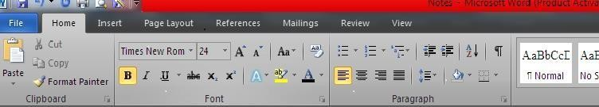

**B**- Make the Letters **Bold** (Dark)

*I*- Make the Letters *Italic (Crooked)*

U- Underline the Letters

A^- Increase the Size of Letters A^-Decrease the Size of Letters

Aa^- Changes the style of the Letter Sentence case

Lowercase UPPERCASE

Capitalize Each Words tOGGLE CASE

# ives Shadow, Glow, Reflection to letters

A- Colors the Letters

ab- Colors The Full Words

**BULLETS **- These are used to put numbers, symbols

# Symbols

1.1.1. Numbers

GIVES **BORDERS**

Shift words to **RIGHT**

Shift words to **LEFT**

**ADDS& REMOVES** the gaps between paragraph

Shift words to **CENTER**



Colors the full sentence

Shift words properly to **LEFT&RIGHT**

# HOW INSET SHAPES?

Go to **INSERT- Shapes**

# HOW INSETCHARTS?

Go to **INSERT- Charts HOW INSET PICTURES?**

Go to **INSERT- PICTURES**

# Select the place where PICTURES are keptand Select the PICTURE then Click INSERT.

**HOW INSET TEXTBOX?**

It is used to write letters

Go to **INSERT- Text Box** and **Select anyone** you like**.**

# HOW INSET AUDIO?

Go to **INSERT- AUDIO**

# Select the place where AUDIOis Keptand Select theAUDIOthen Click INSERT.

**HOW INSET VIDEO?**

Go to **INSERT- VIDEO**

# Select the place whereVEDIOis Keptand Select the VIDEO then Click INSERT.

**HOW INSET TABLES?**

# Click on INSERT- TABLES- Insert Tables- Put Number of Rows and Columns-Ok . Add Rows or Columns

* + 1. **Right Click** in a **cell above or below** where you want to add a **Row**

Go to **INSERT**- **Insert ROWSabove or below**

* + 1. **Right Click** in a **cell left or right** where you want to add a **Column**

Go to Insert-**InsertCOlUMNSabove or below.**

# HOW TO STYLE THE PICTURES?

Select the Picture- go to **Picture format**–**select picture style** Give **Picture Border, Picture Effects, Picture Layouts** Adjust the **position of Picture**

**Picture behind** the Letters or **Picture in Front** of Letters

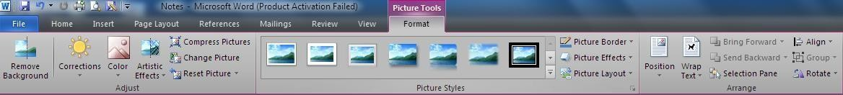

**HOW TO STYLE THE PAGE IN MS WORD?**

Go to **Page Layout** then Select which you want



**COLORS THE PAGE**

**GIVES PAGE BORDER**

**MAKES PAGE**

**VERTICAL OR HORIZONTAL**

**ADJUST PAGE MARGIN**

**GIVES DESIGN TO PAGE**

# HOW TO DESIGN THE PAGE IN MS POWER POINT?

1.Go to **Design** then Select which **THEME** you want

# THEME



**MAKES PAGE**

# VERTICAL OR HORIZONTAL

1. Go to **TRANSITIONS**then Select which **TRANSITION**you want
2. Go to **EFFECTS OPTIONS**then Select which **EFFECT** you want 4.Select the **SOUND** and **TIME** which you want

5.First **Select** the **WORDS** or PICTURES you want to **Animate.**



1. Go to **ANIMATIONS** or **ADD ANIMATIONS**

then Select which **ANIMATION** you want.

1. Go to **EFFECTS OPTIONS** then Select which **EFFECT** you want
2. Select the **TIME** which you want the **ANIMATION** to remain.
3. Adjust which Animation **will come after other**

10. Go to **SLIDE SHOW**-

# SELECT From Beginning (Slide Show begins from FIRST SLIDE)

**SELECT From Current Slide(Slide Show begins** from the **CURRENT SLIDE**)

**XVI. How to USE Ms- Excel?**

**HOW TO CALCULATE TO PERCENTAGE?**

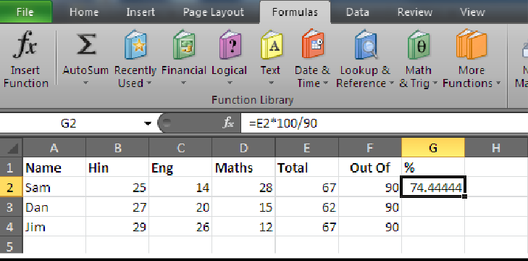

Write all marks- Calculate the total- select the adjacent cell write the formula = Marks Got*100/ Total Marks

In above example (=E2*100/90).

# HOW TO SORT ASCENDING OR DESCENDING ORDER?

**One –Column Sorting**

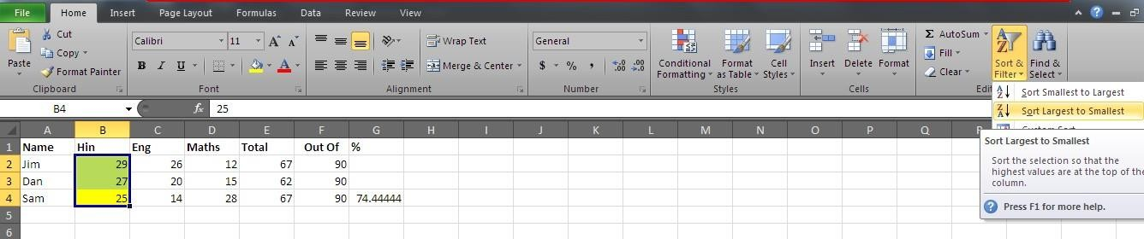

# Adjust Descending order of Hindi Marks

Click anywhere inside Hindi Marks (eg –B4:25) – Home- Editing group- Sort& Filter – Sort Largest to Smallest

# Multiple - Column Sorting: Adjust Descending order of Hindi Marks + Names in Ascending Order

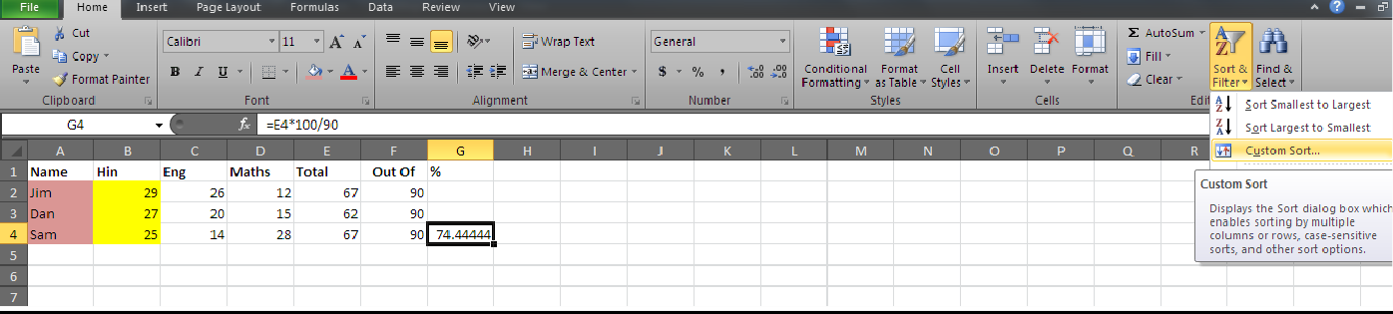

Click anywhere inside table – Home- Editing group- Sort& Filter- Choose- **Custom Sort**

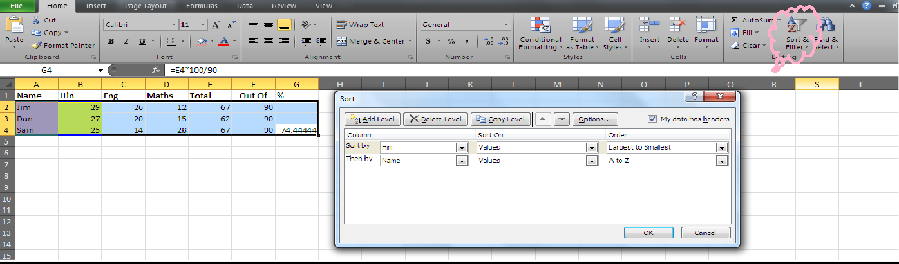

In Sort by Column- Select **Hin**

Order by Column- Select **Z to A**

Click **Add Level**- by Column- Select **Name**

Order by Column- Select **A to Z**

Press **O.K.**

# HOW TO FILTER DATA?

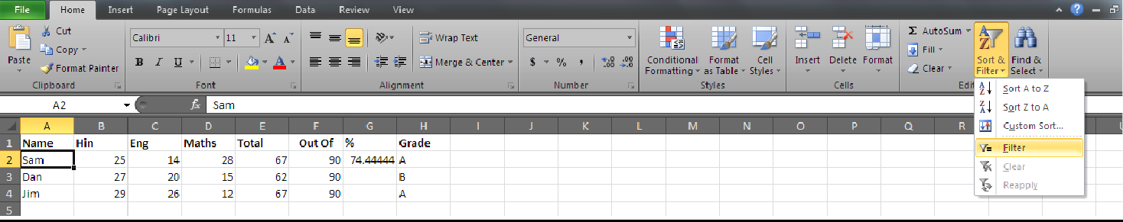To **display** all Records that has **Grade A**

Click anywhere inside table – Home- Editing group- Sort& Filter- Choose- **Filter**

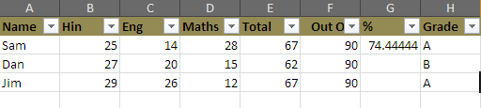

Drop-down controls will be displayed – Click on any one of the drop- down control you want to filter If you have selected **Grade A, only the A will be displayed**

**1.** Deselect all grade by clicking on **Select All** then click on **A**

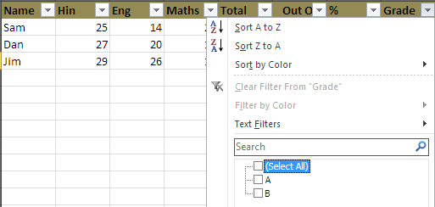

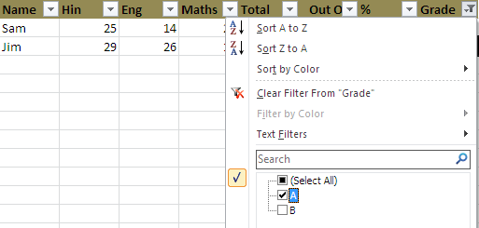

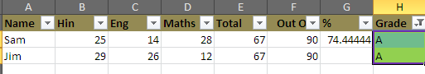

# HOW TO CONDITIONAL FORMATTING?

Select Format- Conditional Formatting and select the **total column** which you want to Conditional Format

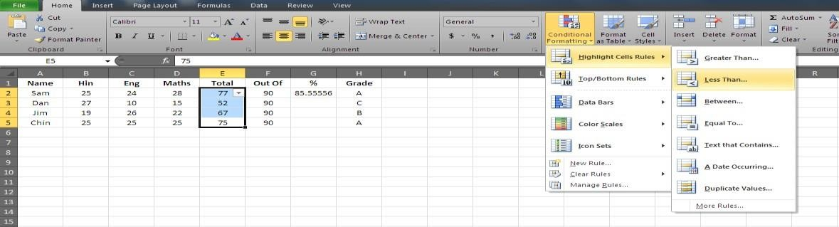

This will display **Conditional Formatting** dialog box- **Select lesser than 70 and select color- O.K**

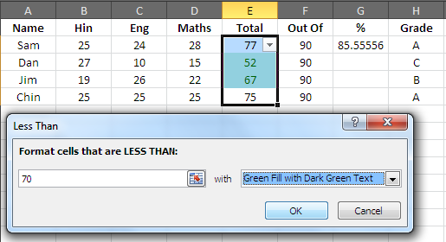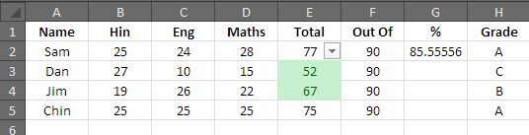

**So all Marks less than 70 will be highlighted**.

# TYPES OF CHARTS IN MS EXCEL?

**Line chart-** When many points to plot.

**Column chart-** Height is important than trend among data points.

**Bar chart-** Categories vertically and values horizontally. **XY chart-** Many points and no particular trend (Scattered) **Pie chart-** Single data

**Doughnut chart-** Relationship of parts to whole. More than 1 data. **Area chart-** Emphasizes magnitude of change in data over time. **Radar chart-** plots data in concentric circles.

**3-D Surface chart-** 3-D view of data- e.g. topographic map.

# IMPORTANT MENUS USED IN CHARTS?

**Title-** Various titles for Chart title, x-axis title, y-axis title.

**Chart title-** Placed at top of chart. Understand the chart.

**Axis title-** Specify type of scale for axes x,y,z.

**Legend-** to right of the plot area is legend. Identifies each data series by giving unique colour/ pattern, **Grid lines**- Displays gridlines on Major and Minor intervals. Helps to identify value of each data point on chart.

**Data Label- gives** additional information about data marker, which represents single data item or value coming from a worksheet cell.

Specifies series name, category name, and value.

**Data Table-** Shows data table - displays data of table from which Chart was drawn- Next to display Chart location dialog box. In the Place Chart – Choose Create chart on New Sheet- Select as New Sheet- give name or Choose embed (place) the chart in existing sheet- Finish.

# HOW TO CREATE A CHART?

Enter data into worksheet

Select Range of data for which you want chart- If you want – Columns + Rows labels to appear select it also.Select Chart from Insert menu- Choose Chart

Click Next- Chart Source Data dialog box. (You can change the data or labels for the chart- Click Data Range Box – Select source range from sheet)

If you click on Series tab of Chart Source data- In Series field- Change legend box text to reflect column headings- Click Next- Chart options.

# HOW TO DO MAIL MERGE IN MS WORD?

Need to send letters with identical information to group of people who reside at different locations use Mail Merge.

1.Creating main document - Fixed data 2.Creating data source - Variable data 3.Merging – Data + Source joined.

# HOW TO CREATE A MAIL MERGE DOCUMENT IN MS WORD?

Select Tools - Letters and Mailings – Mail Merge.

Select Letters – Click Next: Starting document (Step 1 of 6)

(Step 2 of 6) Select starting document-

a.Current doc- Start from doc displayed on screen b.Start template- Ready – to – use format

c.Start existing- Allow to use existing doc Click Next: Select recipients

(Step 3 of 6) Select recipients –

1. Existing list- Already created contact list.
2. Outlook contacts- From Microsoft Outlook contacts
3. Type new list- To create new contact list

Click Type new list – Create – Enter address – Click New Entry

After typing all address – Click on Close button.

Save Address list dialog box appears – name it – Save. Mail Merge Recipients window appears – OK

Click Next: Write your letter

(Step 4 of 6) Click More items – Insert Merge Field – Click on field name – Insert button – Close button – Repeat.

After all merge fields are inserted, type your LETTER – Click Next: Preview your Letters

(Step 5+6 of 6) Click Next: Complete the merge – Print / edit letter individually / Merge all records or selected records - Save

**HOW TO USE MS- ACCESS**

Ms- Access allows you to **manage, store information** in **TABLES**

# HOW TO START MS- ACCESS

Click on Start – Programs – MS Office – Ms Access

Click File Menu- New – Blank database – File New Database Type name – Create

# HOW TO CREATE TABLE? – DESIGN VIEW / TABLE VIEW / DATASHEET VIEW. USING DESIGN VIEW –

Select and double click on Create table in Design View’

Type name in 1st empty box in Field Name column – Press Tab

Next column an arrow appears for a drop down list. Click on it to open Data Type list- select Data type Press Tab- next column Type desired details regarding Description.

Repeat the above steps for more entries – Click Close – Yes to Save. Ex: Create table ‘Teacher’ in the Design View.

|  |  |  |
| --- | --- | --- |
| Field Name | Data Type | Description |
| ID- No | Number | Stores teacher’s identity number |
| T- Name | Text | Stores teachers name |
| Dept | Text | Stores teachers department |
| Salary | Currency | Stores teacher’s salary |

# USING TABLE WIZARD -

Feature allows you to choose tables having predefined fields Select and double click on ‘Create table by using wizard’

Select ‘Business or Personal’ – Click required items from Sample tables- Select specific fields from sample fields by pressing ≥ button.

To remove selected fields Press ≤ button. Press ≥≥ include all sample fields and Press ≤≤ remove all. Click Next – Type Name for table – Click Yes to set primary key or Click No if you do not want to set primary key.

(**Primary Key-** in Table if you want 1 field should have unique values for each record then set it as Primary Key field.

Eg- Field of Employee- ID as Primary Key. Primary Key does not allow empty values.

Ms Access will **not allow you to delete a Primary Key Field**)

Click Next – Select field which will have unique data in it Click Next – Select Enter Data directly in Table – Finish.

Ex: Create Table using Wizard the table should have fields related to Business such as – 1st Name, Last Name, Title, Name of Organization, Address.

# BY ENTERING DATA –

Select and Double Click on ‘Create’ table by entering data.

Click in 1st empty cell – Type records – Use Tab to move from 1 column to another File Menu - Save – Enter name – OK

# FORMATTING THE DATE?

Date is entered as **Month / Date / Year** ie default format.

To change – Open table in Design View- Select field having data type ‘Date’- Move the cursor in lower part of screen ie in field of properties plane – Click Format – Select desired format.

# HOW TO SORT THE DATE?

Select field to which Sorting is to be done – Click Sort Ascending Icon.

# HOW TO MOVE THE RECORDS?

**Move to 1st Record Current Record Move to next Record**

Record:|< < 2 > >| >* of 3

# Move to Previous Record Total nos. of Records Move to last Record

**WHAT ARE QUERIES?**

They are records which fulfills certain conditions and criteria. They are used to obtain, extract / specific information from database

Eg : Display records of students having 70% marks.

# RELATIONSHIP-

For Queries you need to create Relationship among tables.

# TO CREATE RELATIONSHIP?

Click on Tools Menu- Click Relationships – Select Table you want to link together and click on them – Add Drag Primary Key from 1st table and drop it in the other table

You can run Query by clicking ! icon on toolbar.

# HOW TO CREATE QUERIES USING WIZARD ?

Click on Queries tab in Database Window

Double Click on Query Wizard – Select Table to do Query on – Select Field to display in it Selected fields – Click name of query – Finish.

# HOW TO CREATE QUERIES USING DESIGN VIEW?

Double Click on ‘Create query in Design View’.

Add two tables as in Relationships – Close – Query is created. Ex: Open ‘Teacher’ table created earlier

Create Query using Wizard & Design View Display Name & Dept only in Query Table Save your Query

**FORMS:** They are method to display, edit , add records in a table

# CREATE ‘ FORM ’ USING WIZARD ?

Click on ‘ Form ’ tab in database window – Create Form – New – Form Wizard – Ok

Select fields u need in Form – Next – Select layout – Next – Select Style – Next – Form get created Ex: Create a Form for table created earlier.

**REPORTS:** Provides information from a database in organized manner.

# CREATE A REPORT USING WIZARD?

Click on ‘ Reports ’ tab in Database Window – Select Create Report by using Wizard option – New – Select Create Report by using Wizard option – New – Select ‘ Report Wizard ’ – Ok

Select fields you want in report – Ok

Select fields you want to group – Click Next Select Sorting order for your record – Next Select Layout – Next – Select Style – Next

Type name for Report – Preview Report – Finish (Notice Report gets created.)

Change design of your Form and Report by clicking Design button available on the toolbar Create Report of Table created earlier.

**HOW TO USE HTML?**

Web pages are created with the help of a special language called **HTML**

HTML **describes the structure and appearance** of a web document

|  |  |  |
| --- | --- | --- |
| HTML- **Hyper Text** | **Markup** | **Language** |
| (Text which has | (Code assigned with | (Used to create web pages) |
| Link to other doc) | help of tags – Special symbols) | |

Original HTML doc was designed – Tim Berner – Lee at Cern (Switzerland)

# TERMS IN HTML:

* 1. (< ,>) **Tags –** Special keywords / commands that instruct browser how to display the particular part of the page.

Tags are not **CasE – SensitivE.**

* + 1. **Container tags –** They are paired i.e. there is an opening & closing.

The closing tag is same as opening / start tag except it (closing tag) starts with a

forward

( / ) slash.

< HTML > text < / HTML >

# Opening tag Closing tag

* + 1. **Empty tags** – They are the tags which has only the opening tag Line break - < BR >

Paragraph mark - < P >

* 1. **Element –** The basic component of structure of HTML doc. It has a opening tag, contents, closing tag

|  |  |  |
| --- | --- | --- |
| **<** B **>** | to make text **BOLD** | < / B> |
| **Opening tag** | **Contents** | **Closing tag** |

* 1. **Attributes** – Special words which give additional information of element They are used inside the opening tag & give ‘**Space’** between Attributes.

Eg: BG COLOR and TEXT are the attributes of < BODY > tag

< BODY BG COLOR = “ YELLOW ” TEXT – “ BLUE ” >

# Space

**How TO STRUCTURE OF A HTML PAGE?**

# Basic Tags used for every HTML doc.

--< HTML > --- < / HTML > - Indicates HTML doc

--< HEAD > --- < / HEAD > - Heading of the doc

--< TITLE > --- < / TITLE > - Title

--< BODY > --- < / BODY> - Main Idea

# Basic Structure of HTML doc

< HTML >

< HEAD >

< TITLE > < / TITLE >

< / HEAD >

< BODY >

< / BODY >

< HTML >

1. Create HTML doc in **NOTEPAD**

Save it as **filename.HTML** / **filename.HTM**

# HOW TO CREATE HTML CODE AND SAVE IT AS FRIENDSHIP.HTM?

*UNTITLED NOTEPAD

FILE EDIT SEARCH HELP

< HTML >

< HEAD >

< TITLE > FRIENDSHIP FOR ME < / TITLE >

< BODY >

Friendship is a tie that binds two hearts together

< / BODY >

< / HTML >